Splunk- Standard Request Triage

-> You'll find a log injection guide at this link, and below it, they've defined from start to finish how to raise a new request.

<https://ejprod.sharepoint.com/sites/SRETools-o365/Splunk-Requests.aspx>

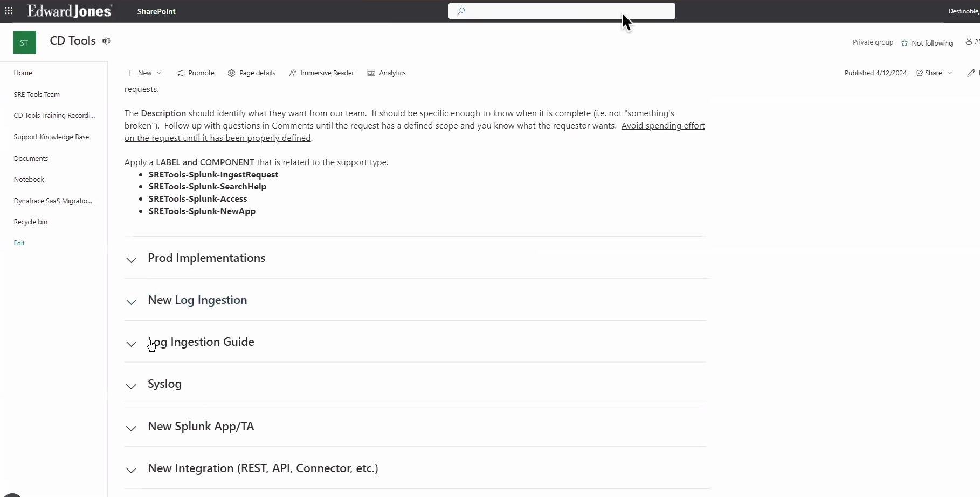

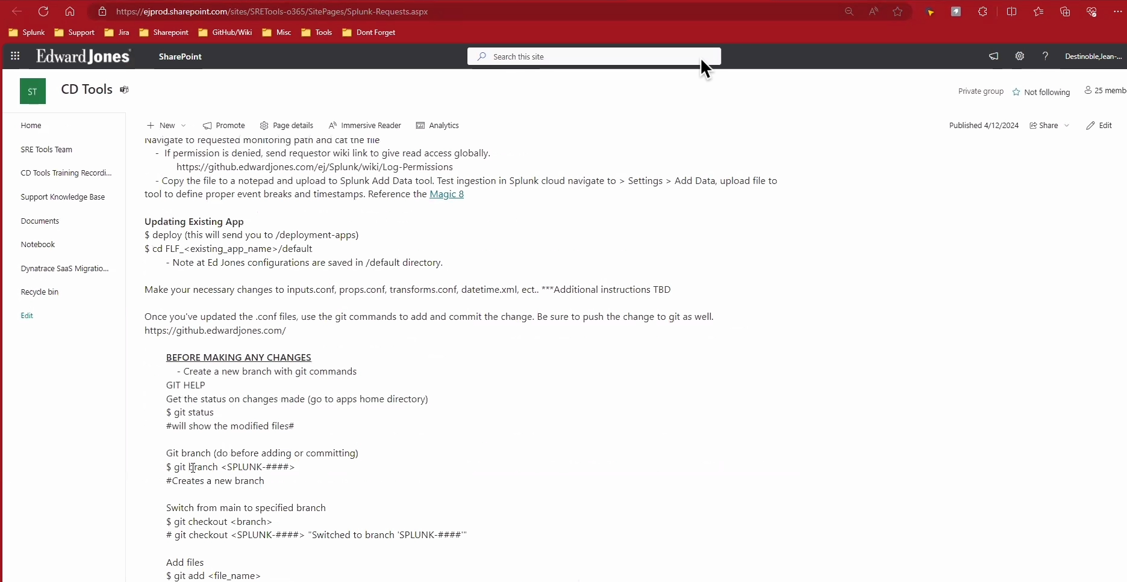

-> In that link, you'll also learn how to create a new Splunk app, which is also mentioned in the log ingestion mode.

-> go to jira :- <https://jira.edwardjones.com/browse/SPLUNK-3019>

-> dropdown more option & select Link

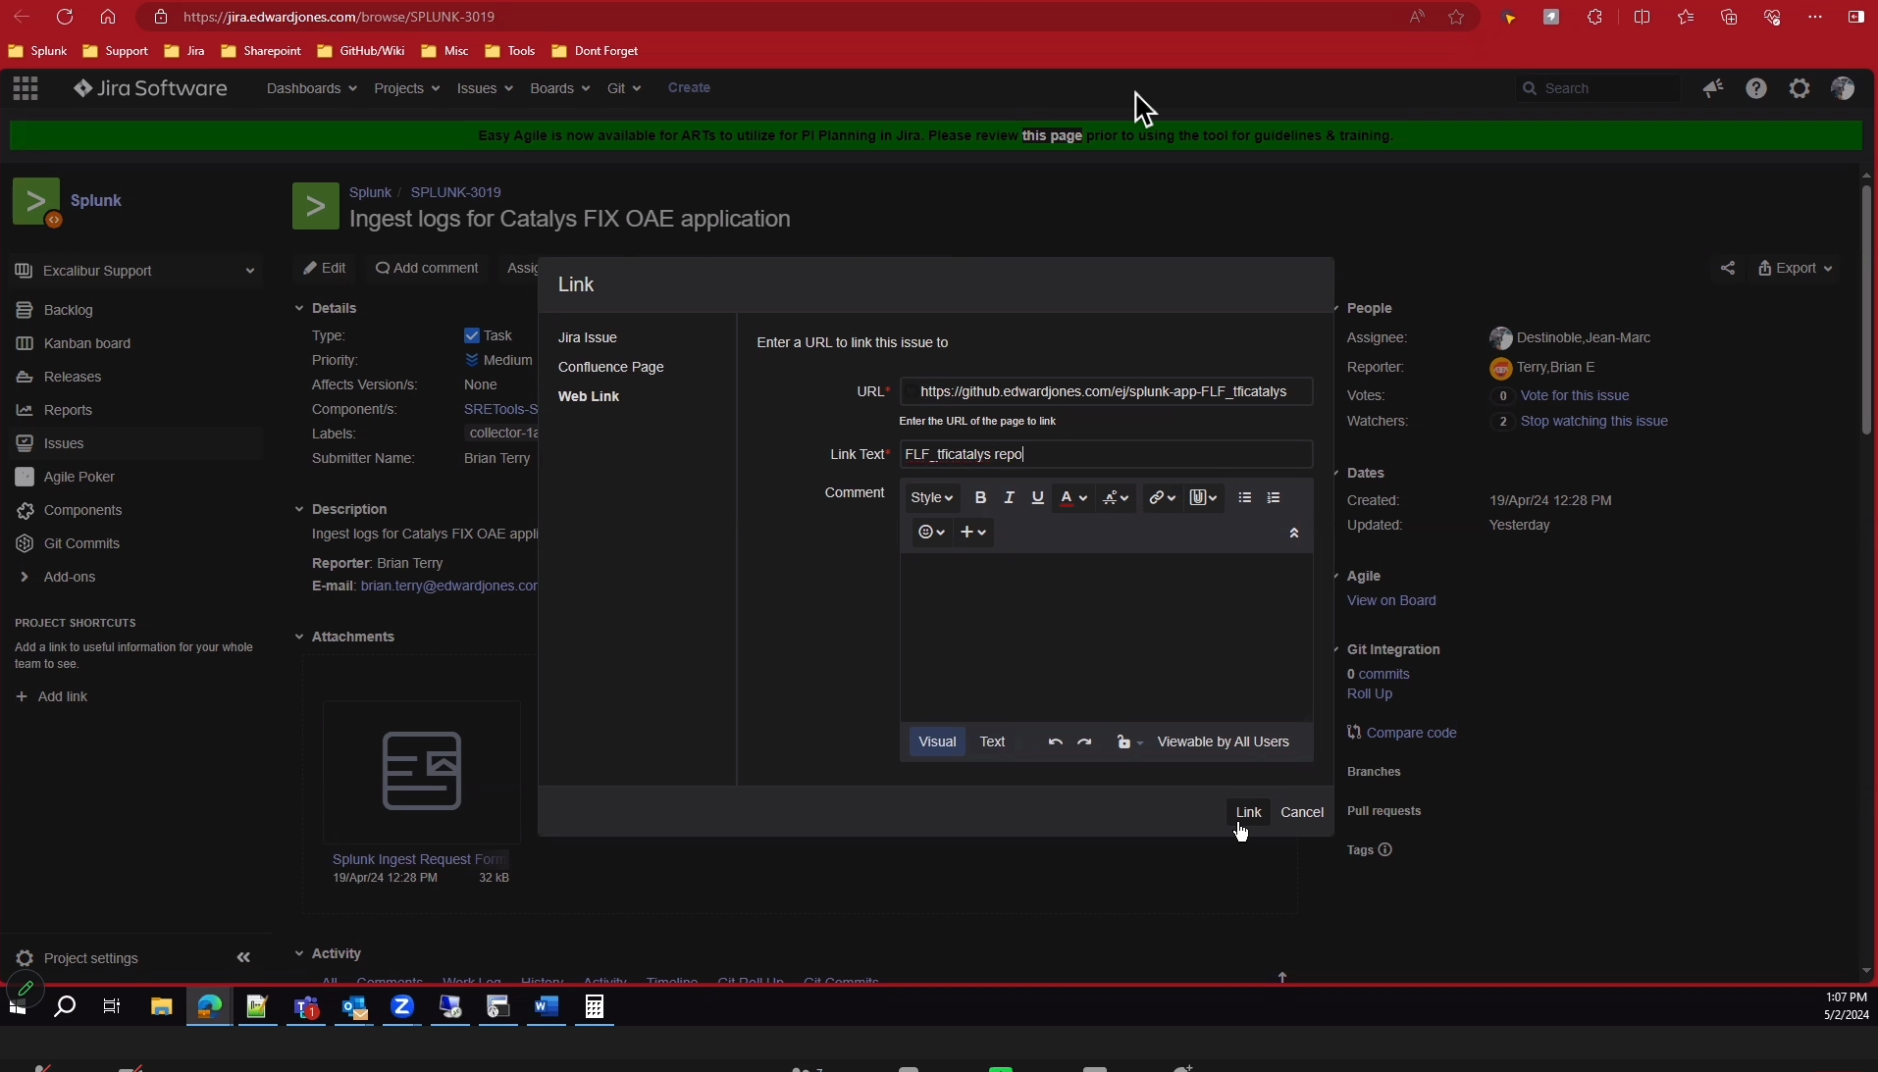

-> For the ticket (SPLUNK-3019) he is creating a new branch SPLUNK-3019

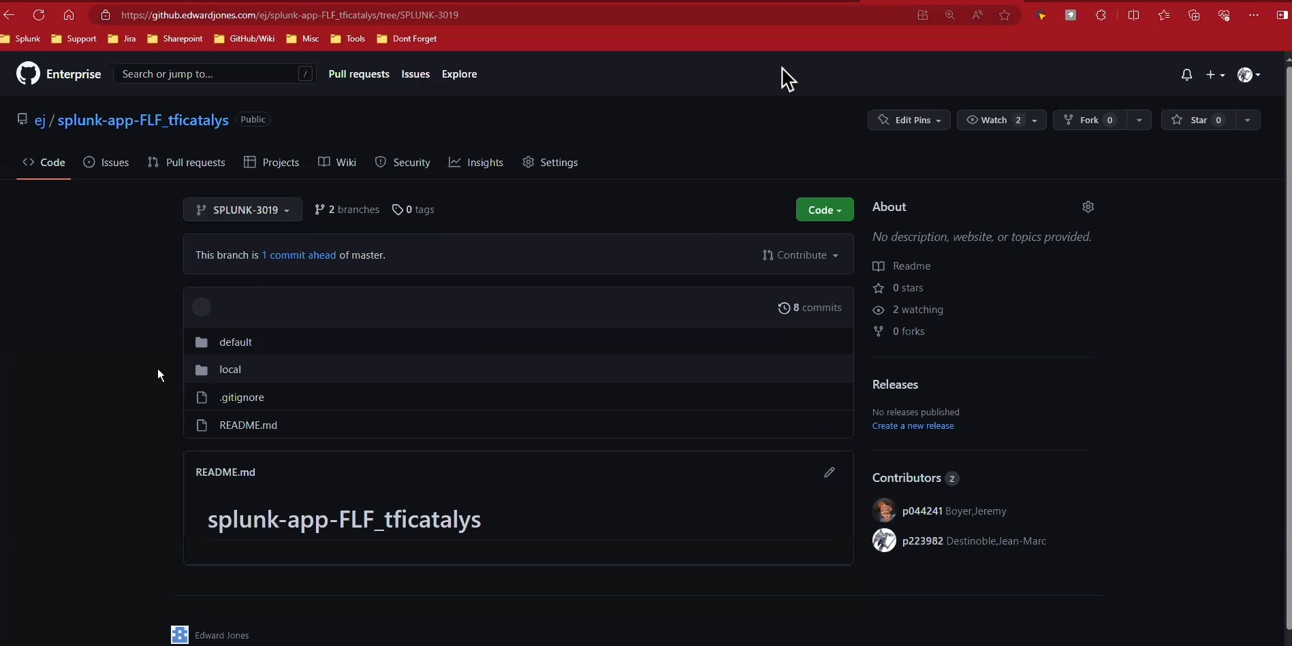

-> go to default & select inputs.conf

-> in Input.conf you can see monitoring path for ticket (SPLUNK-3019)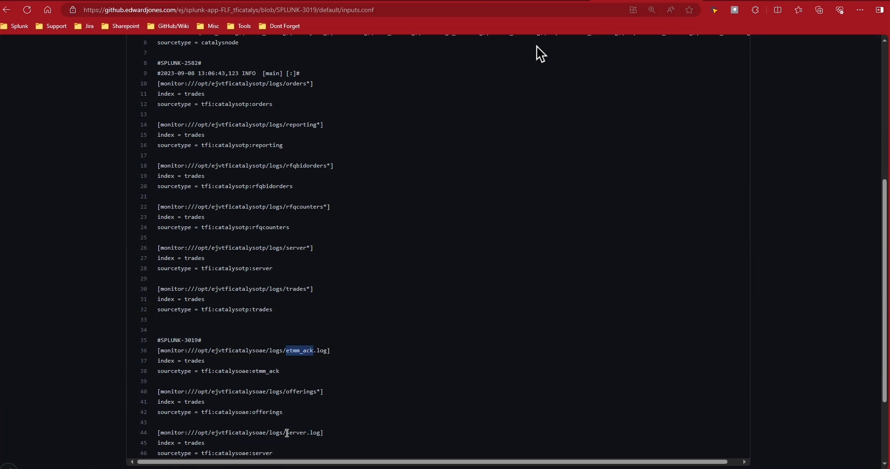

-> here all file names in mention below image

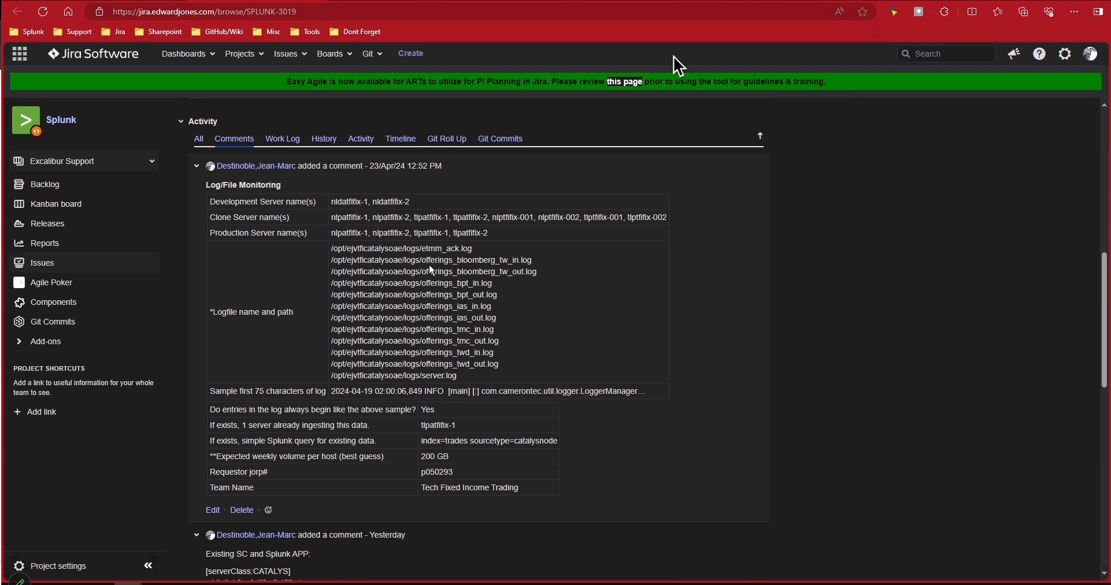

-> if you can see mostly things are mentioned in this restricted document related to implementation plan & also mention backout or revert plan, maybe this thing is not visible to you .

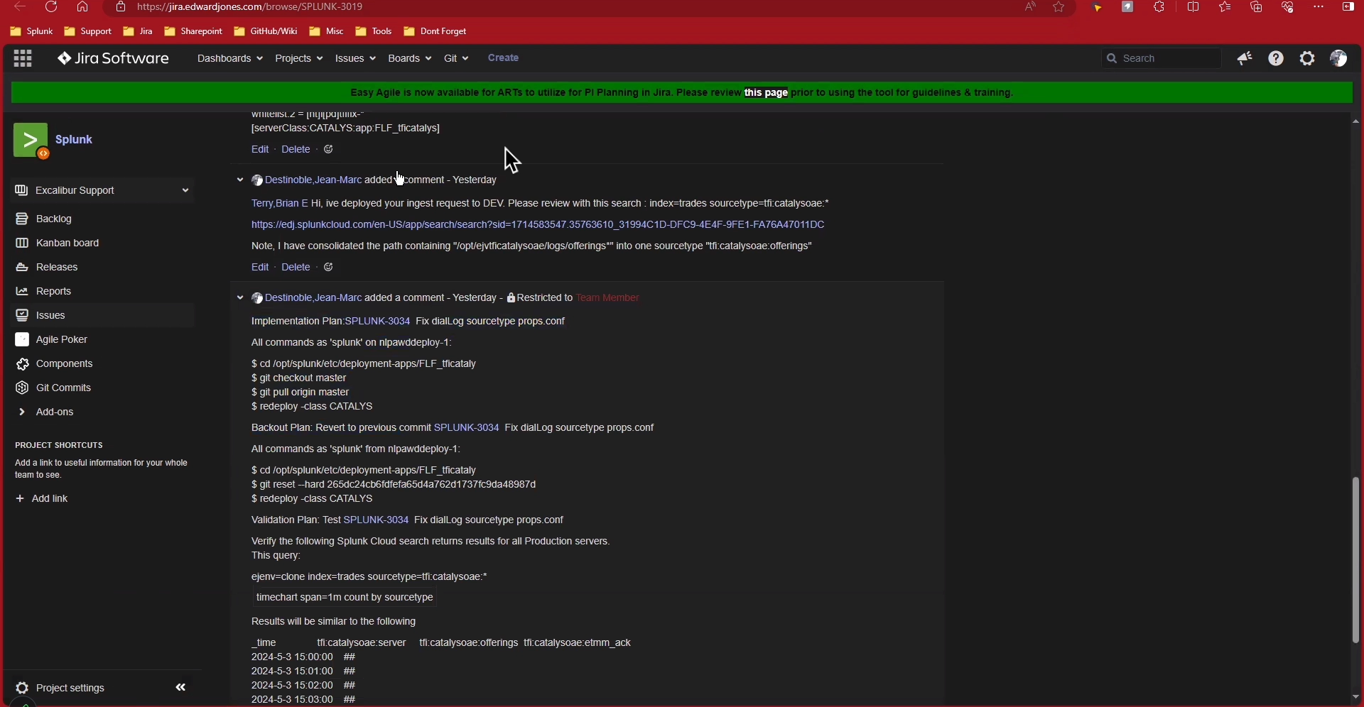

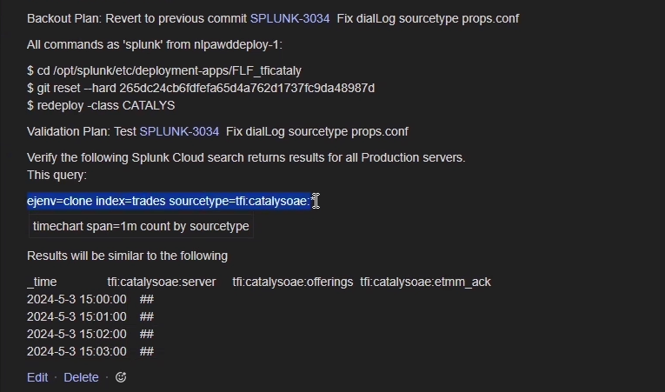

-> for git reset command you need to check latest one

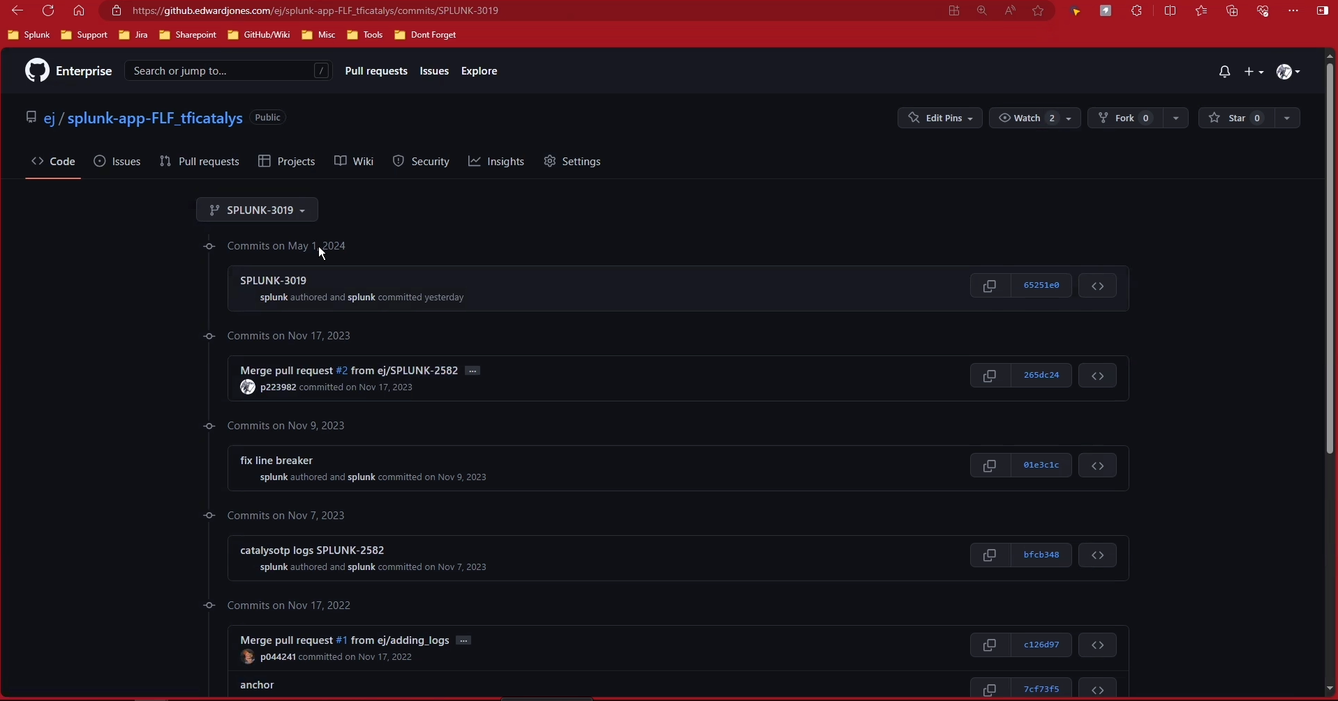

->Now we are create a new change request for clone.

-> in short description you copy a ticket description, and for production related thing you also add stephen in director row also .

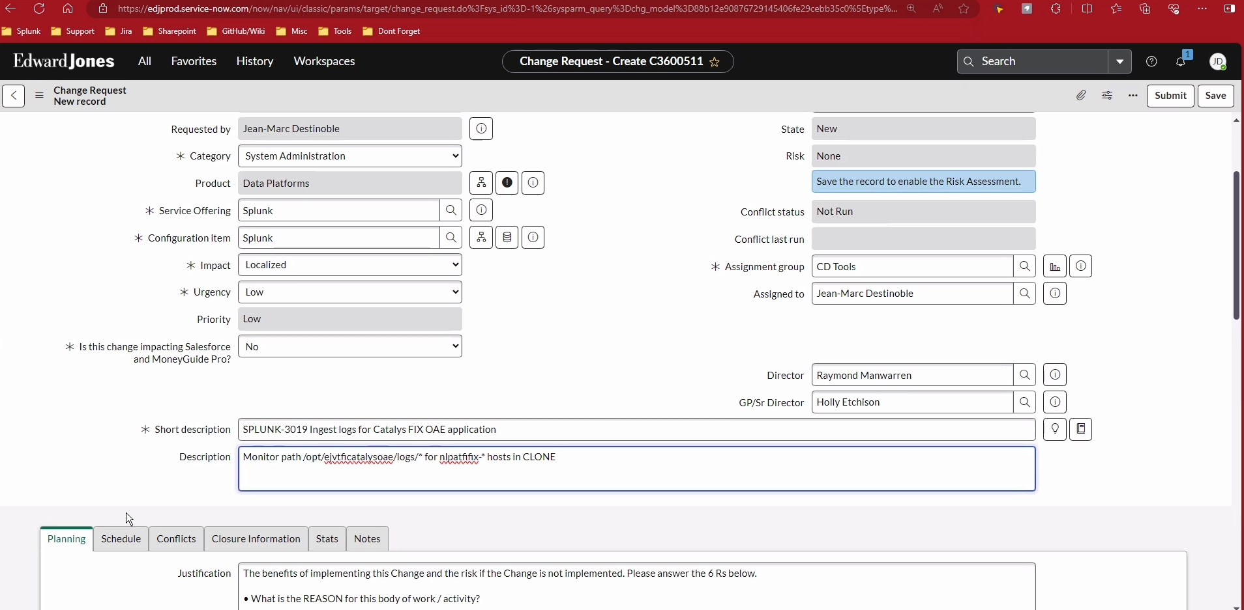

-> add this thing in justification & change accordingly everything related to your ticket

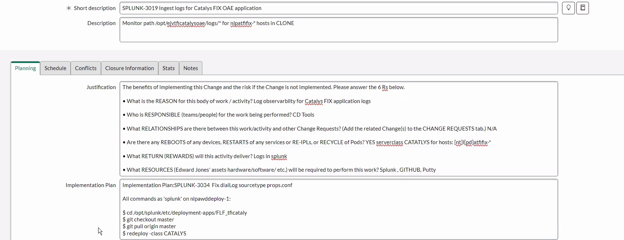

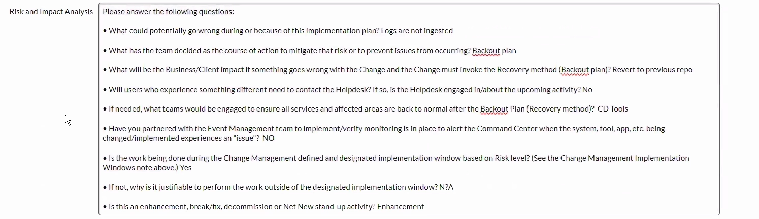

-> for backout plan & Production Validation plan

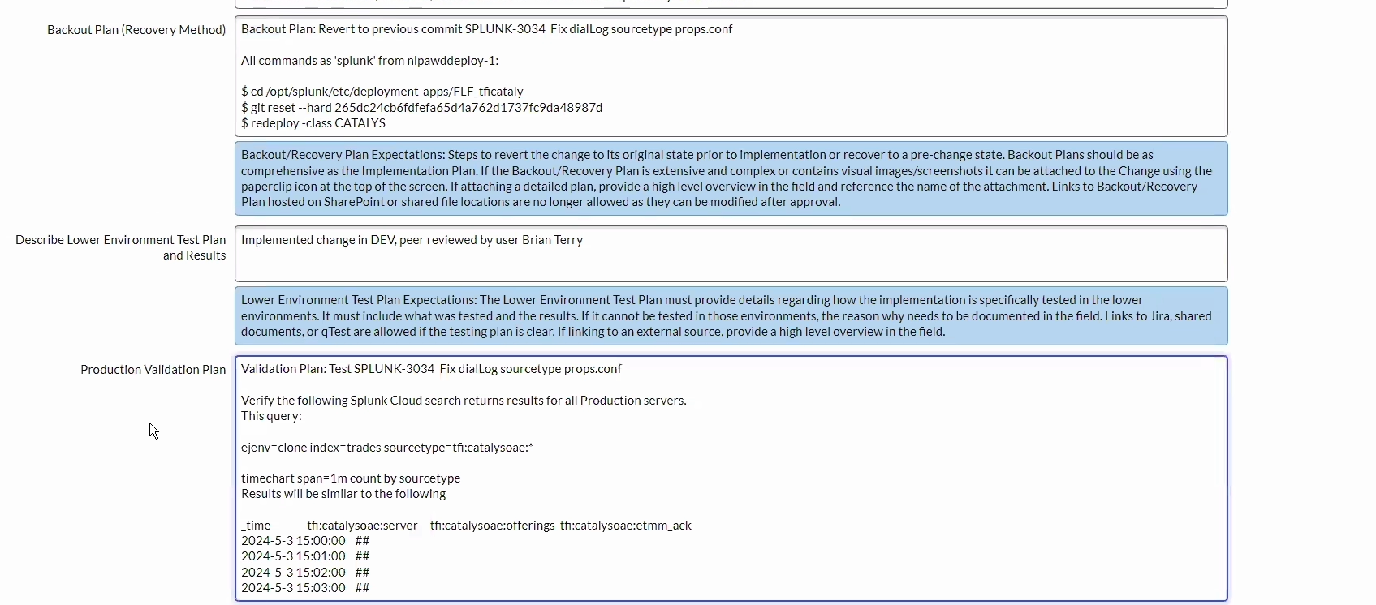

-> check & final submit

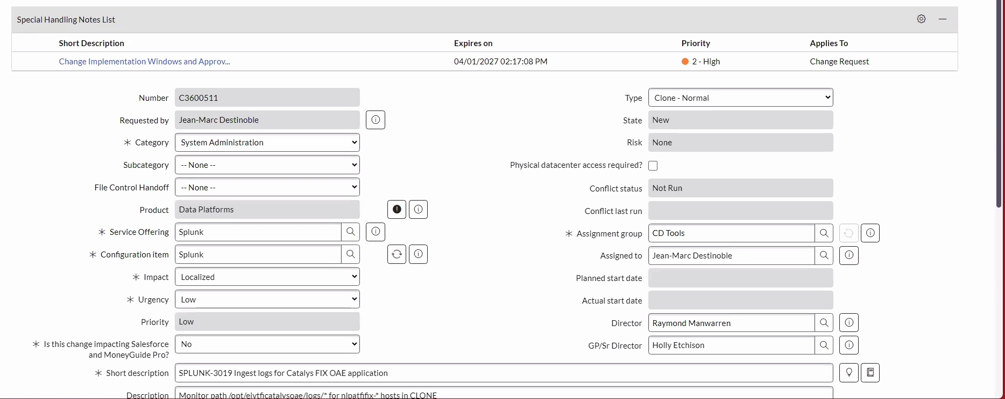

-> select ans

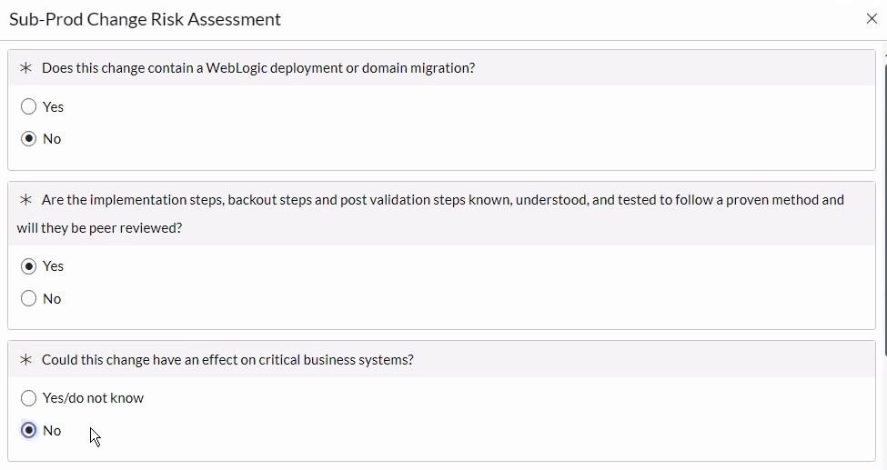

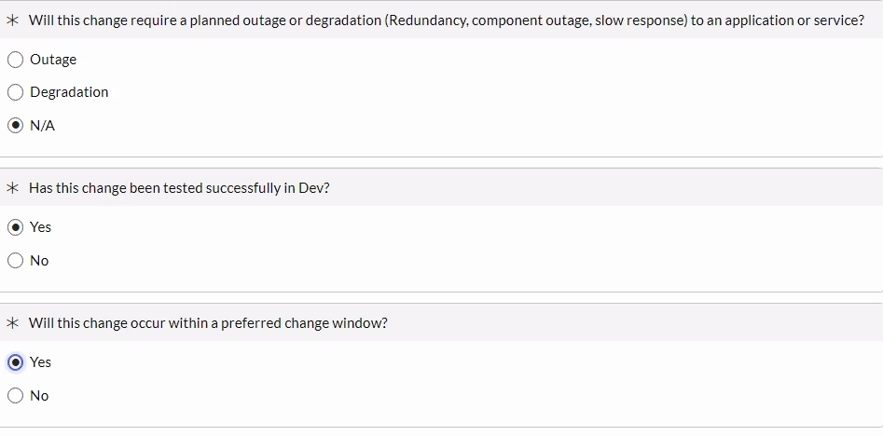

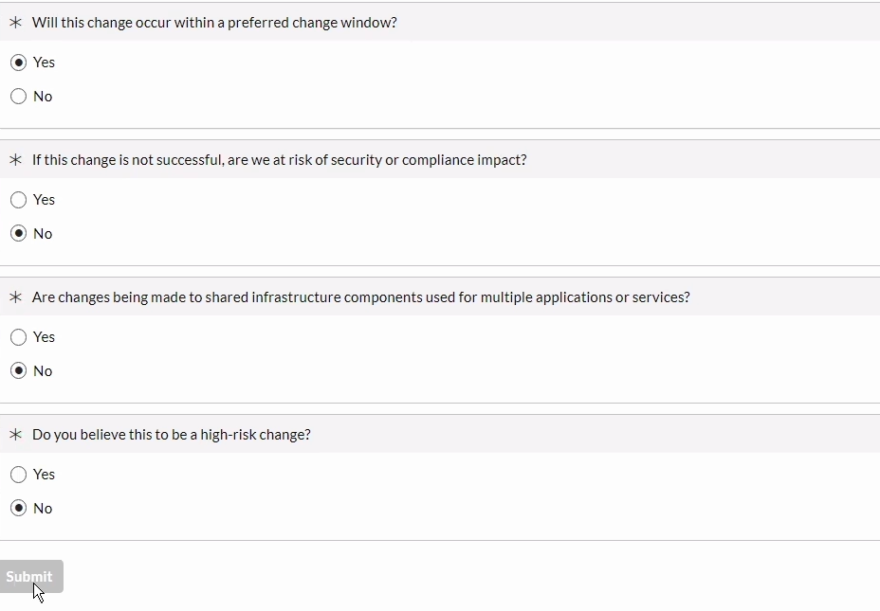

-> select planned start date & end date

